STEPS FOR AZURE DATABRICKS

NAME : Theertha N S
Batch 2 Data Engineer

IN SEARCH BAR TYP E : Azure Databricks

THEN CLICK Create

WORKSPACE NAME : SmartHomeDatabricks

THEN CLICK: Review + Create

THEN CLICK Create

AFTER DEPLOYMENT Launch Workspace

INSIDE DATABRICKS:

AT THE LEFT PANEL: Compute
CLICK Create Compute

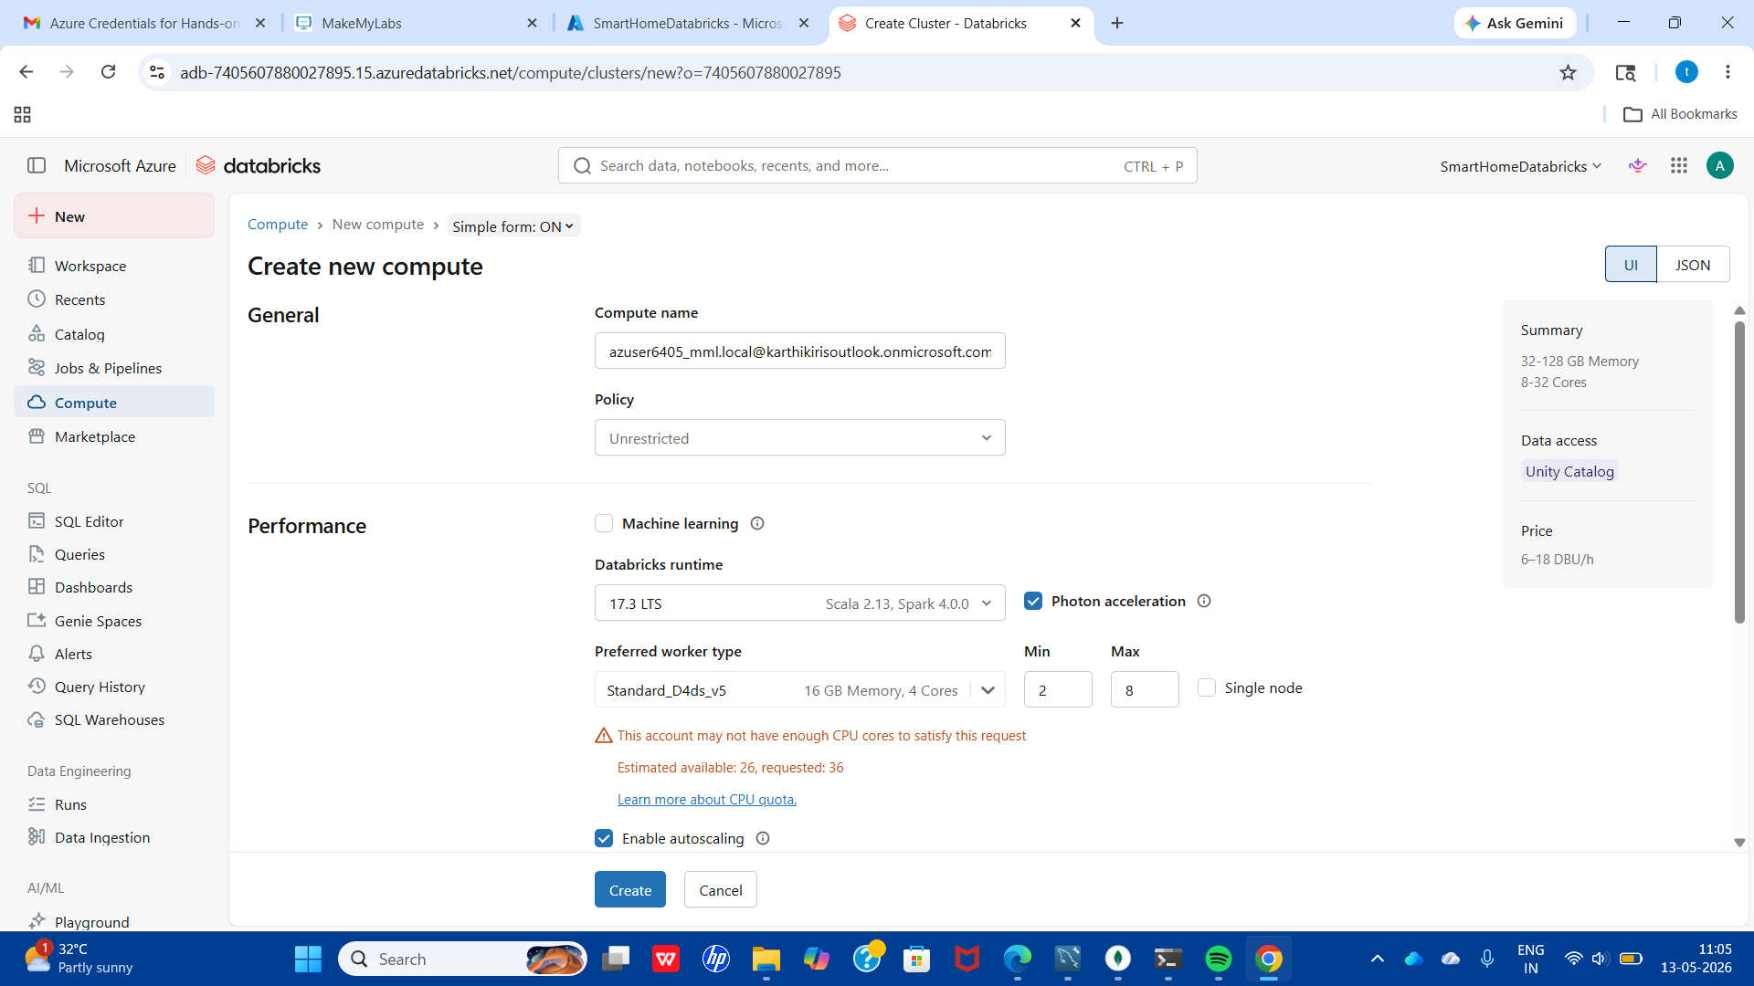

CHECK THE CHECKBOX : Single node
KEEP Standard_D4ds_v5
CLICK Create

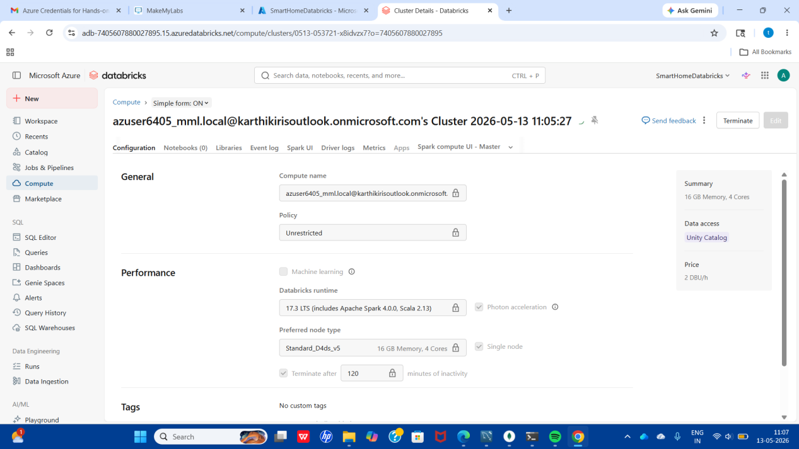

ON THE LEFT PANEL CLICK Workspace
CLICK New
THEN CHOOSE Notebook

THEN CLICK File

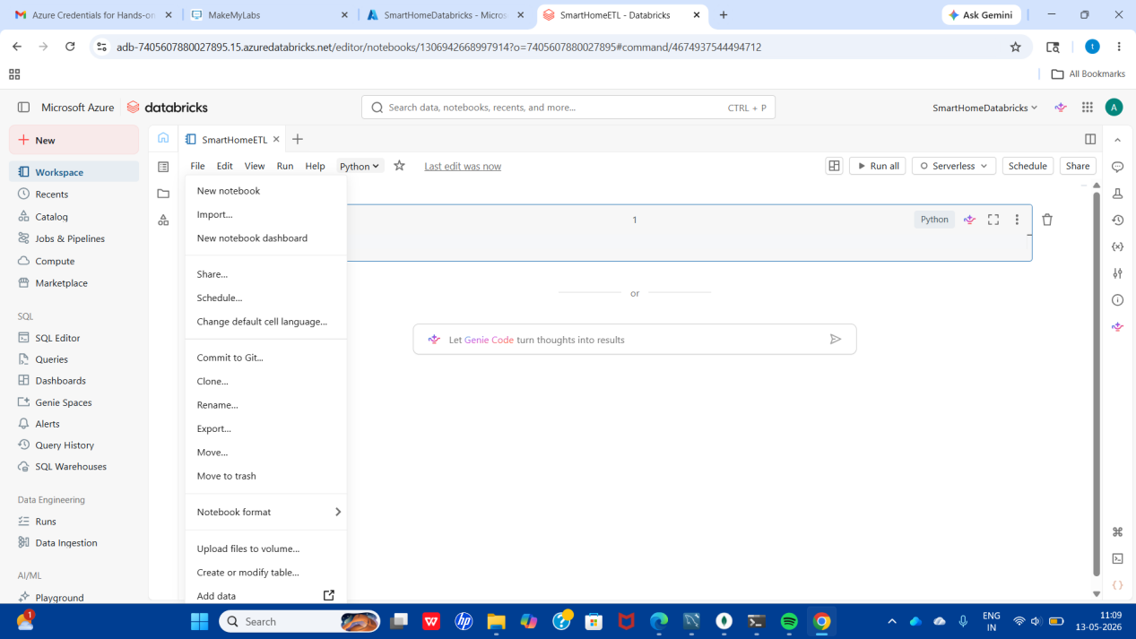

NOW CLICK Add data
THEN Browse
CHOOSE YOUR FILE energy_usage.csv

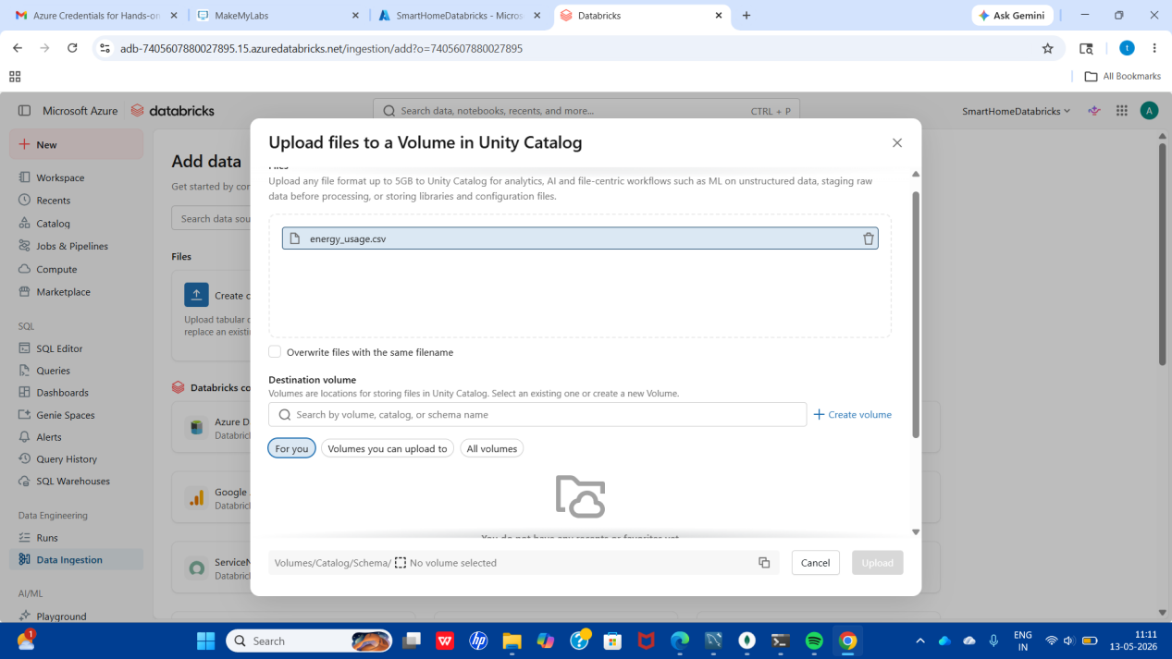

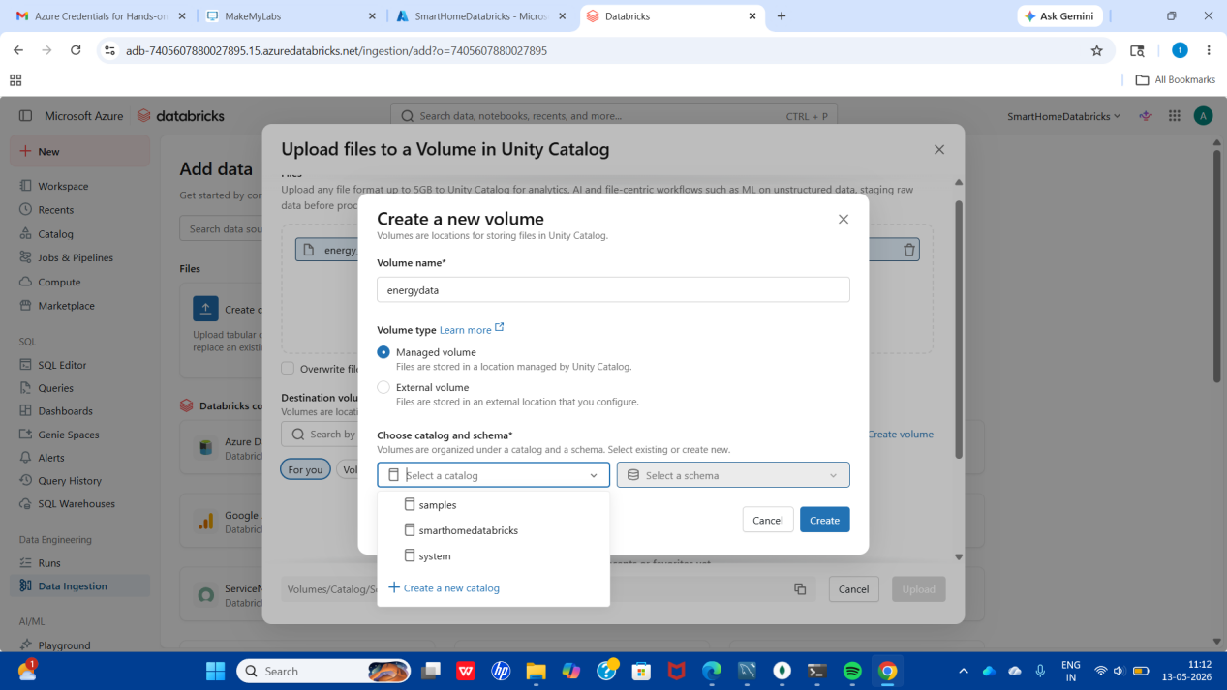

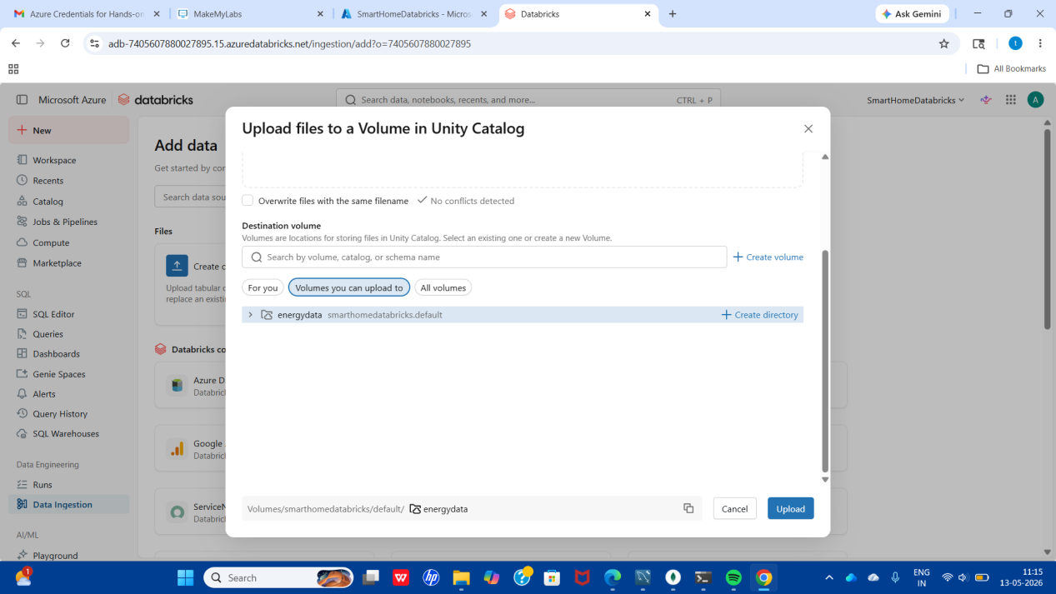

CLICK Upload

GO BACK TO YOU NOTEBOOK

EXECUTE THE ETL CODE

RUN

